**Human Resources Division**

November 18, 2018

**Admit Card**

Photo

**Roll No. :**

**Job Reference No. :**

**Name :**

**Father’s Name :**

**Mother’s Name :**

Applicant’s Signature

**Contact Address :**

**Subject:** **Written Test for the post of Trainee Senior Officer**

Dear Sir/Madam,

We refer to application for the post of Trainee Senior Officer in Shahjalal Islami Bank Limited.

In this regard, you are advised to appear for a written test as per following program:

**Date : November 30, 2018 (Friday)**

**Centre : Mirpur Girls’ Ideal Laboratory Institute, Mirpur 10,**

**Dhaka 1216 (near by BRTA)**

**Time : 10.00 am. to 11.30 am.**

**Please Note:**

1. You must report to the centre by 09:30 AM sharp along with the Admit Card.
2. You should bring with you only black ball point pen.
3. Applicant must use the same signature for application, attendance sheet and answer script.
4. You will neither be allowed to use any digital wrist-watch, calculator, mobile phone, organizer or any other electronic devices, nor any book/note paper in the examination hall. Otherwise you will be silently expelled.

Moreover, Bank will not bear any cost (i.e. travel, hotel etc.) for attending the aforesaid Test.

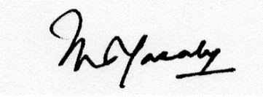

_______________________

**Deputy Managing Director**